Selenium

# Subject: Software Quality Testing

# Section: A

# Group member Details:

# Name ID

1. Zannat, Rahikul 17-33962-1
2. Sakib, MD 17-33659-1
3. Jahan, Nusrat 17-34151-1
4. Sagar, Shamimur Rahman 17-34146-1

### All screenshots of computer during installing Selenium:

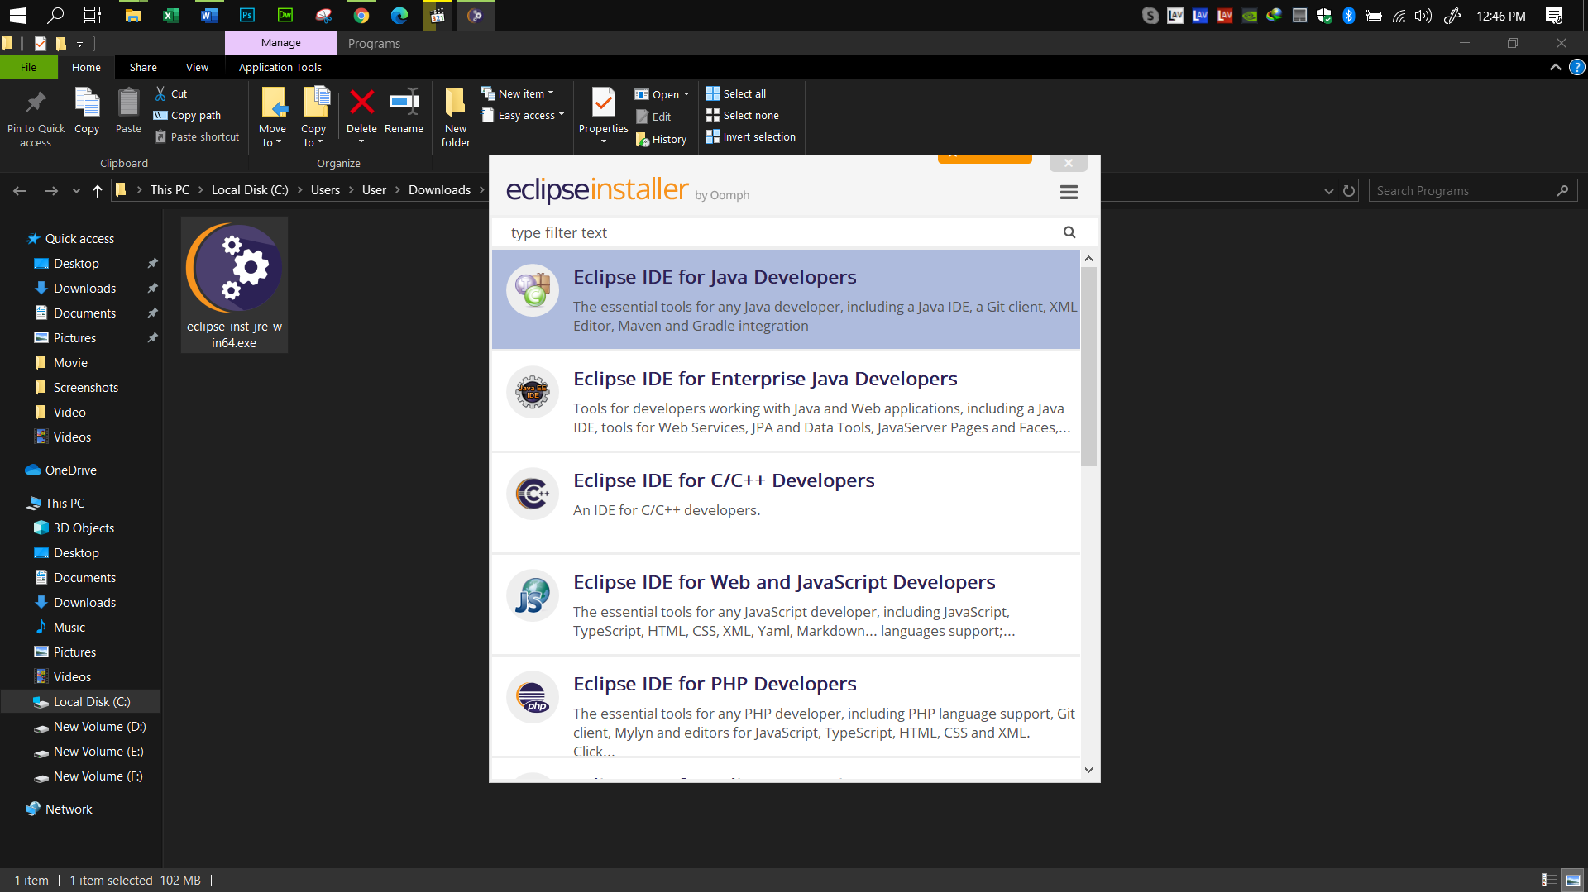

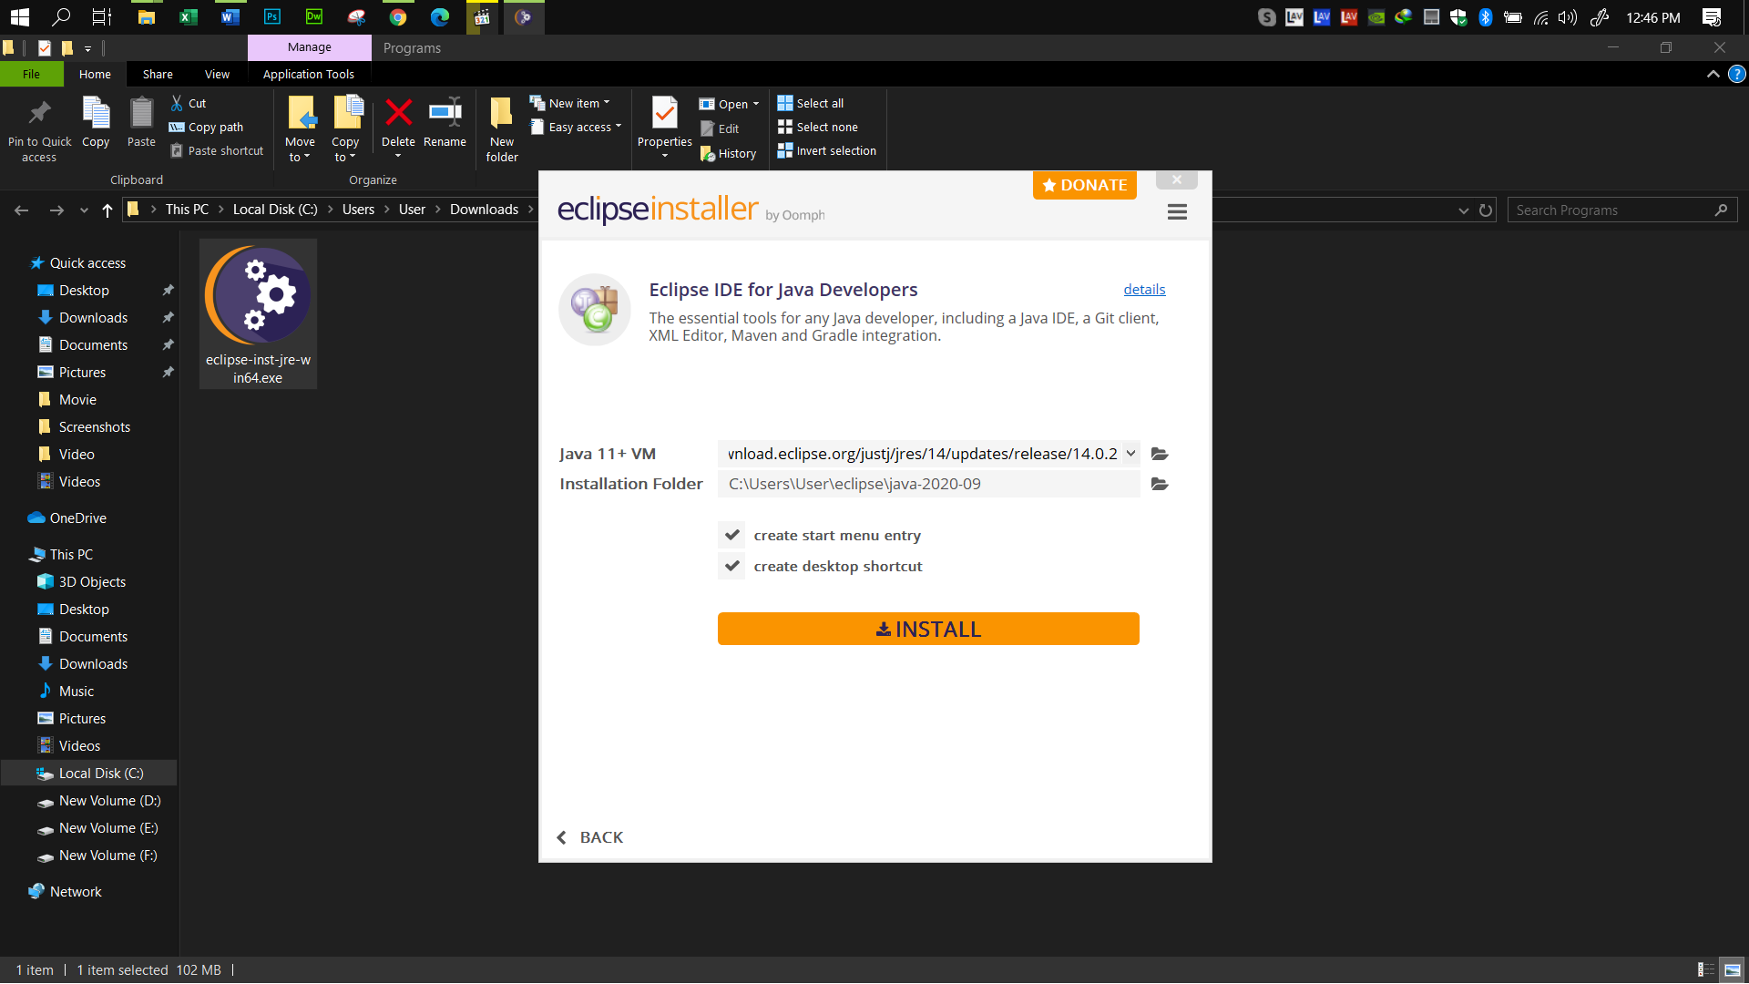

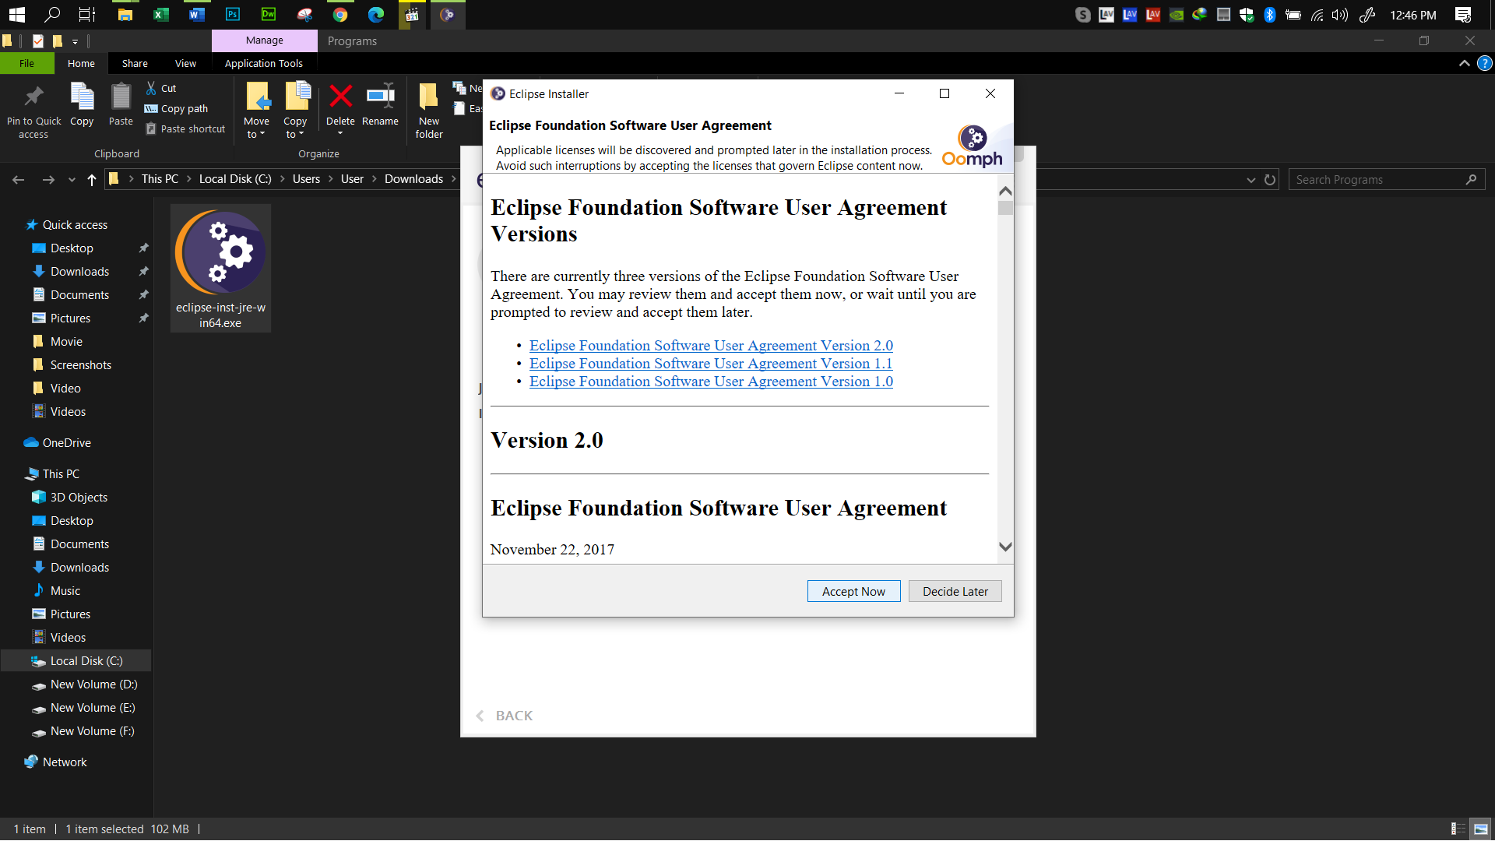

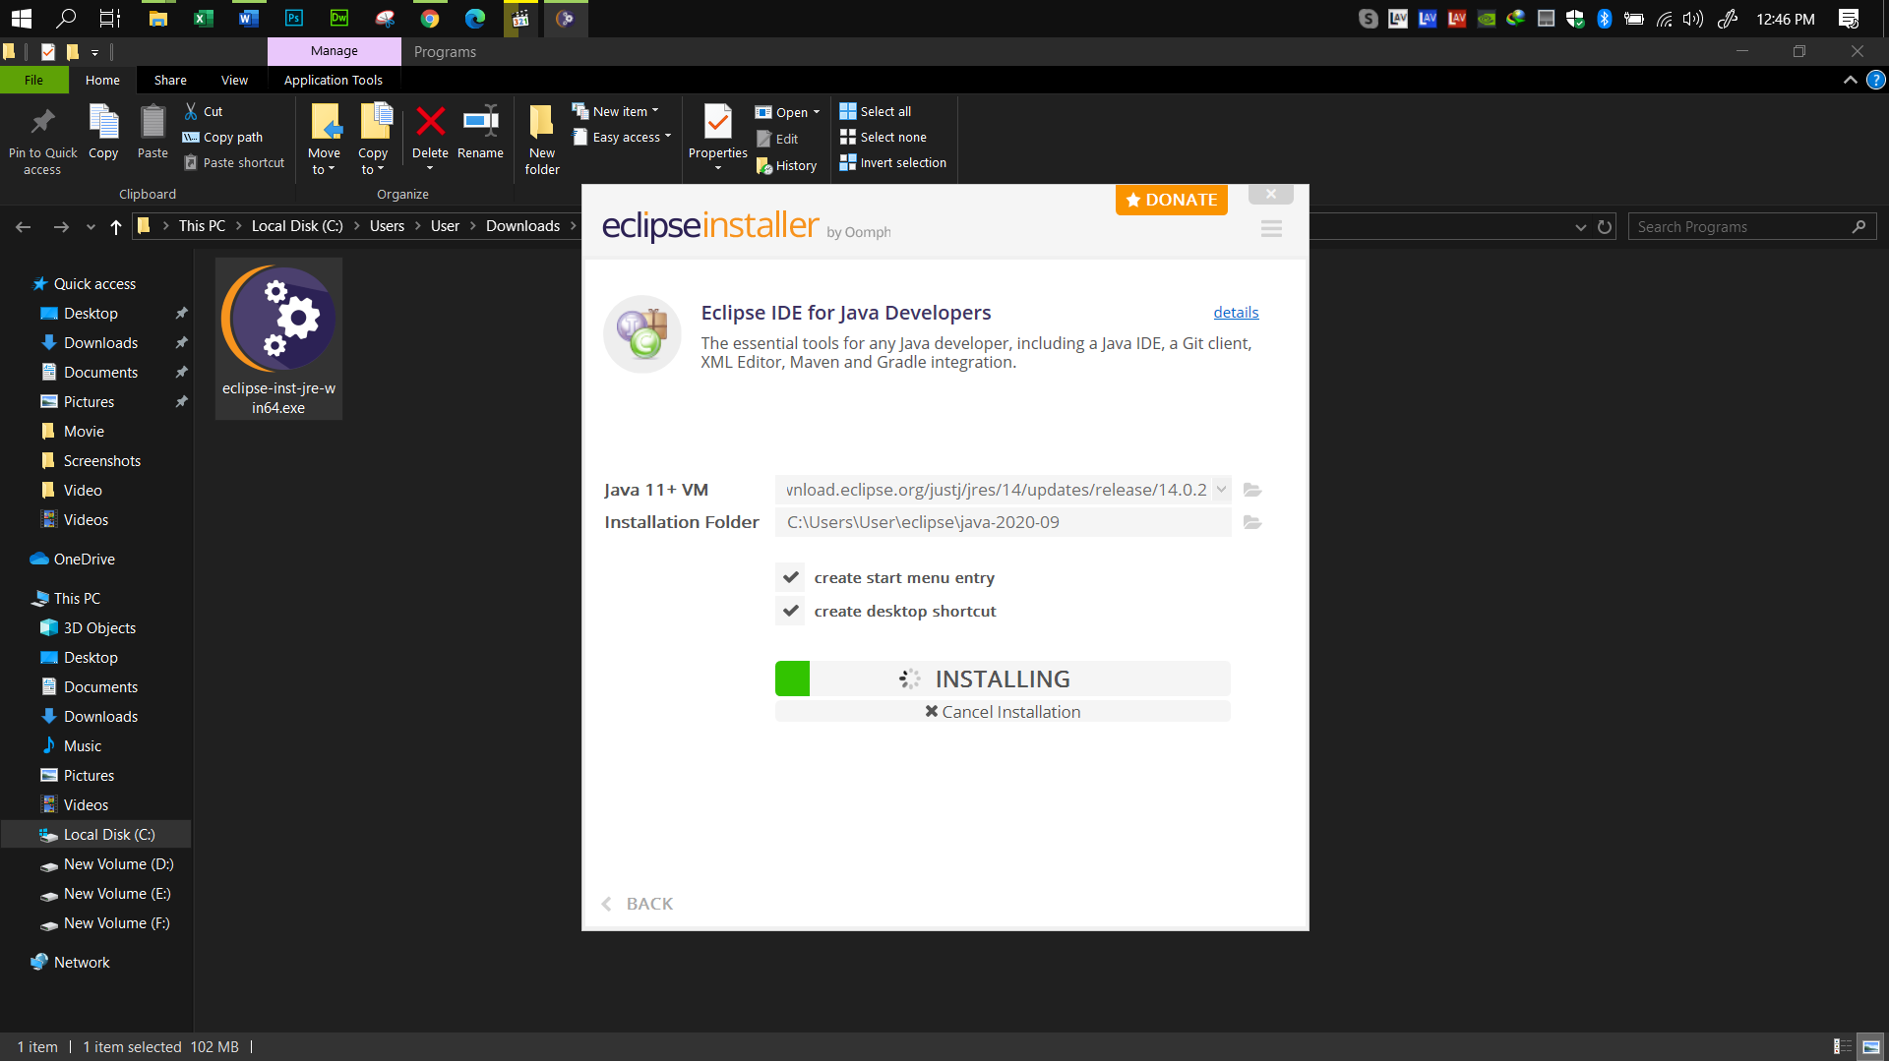

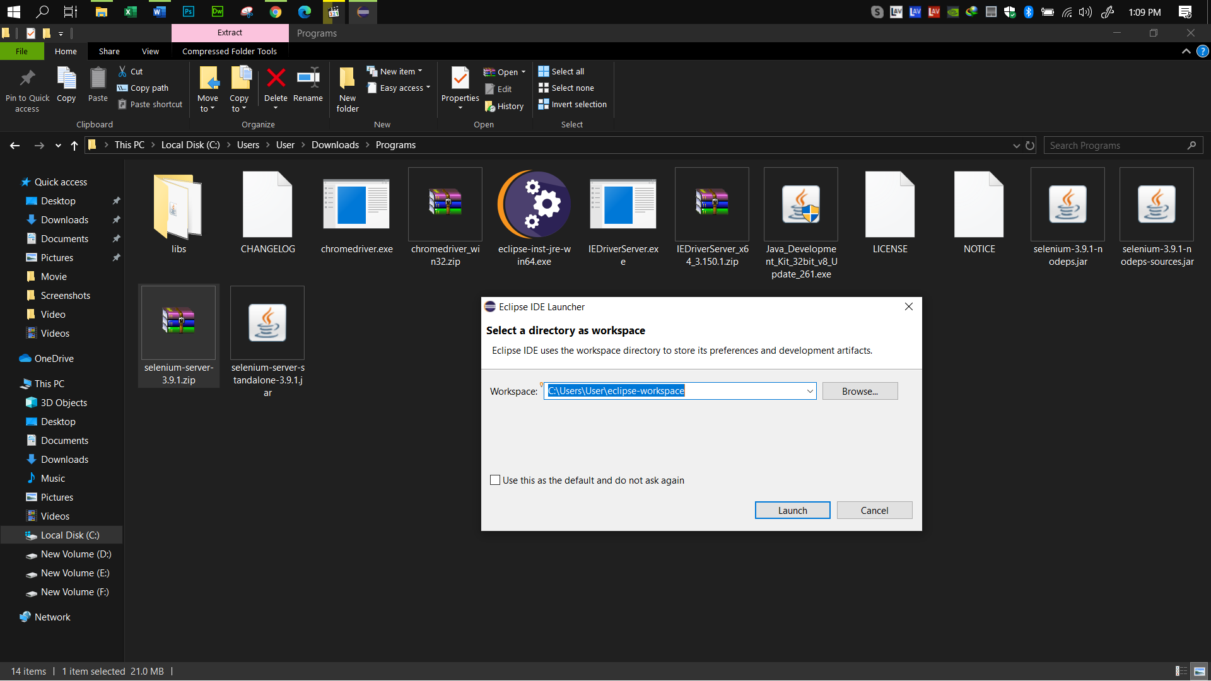

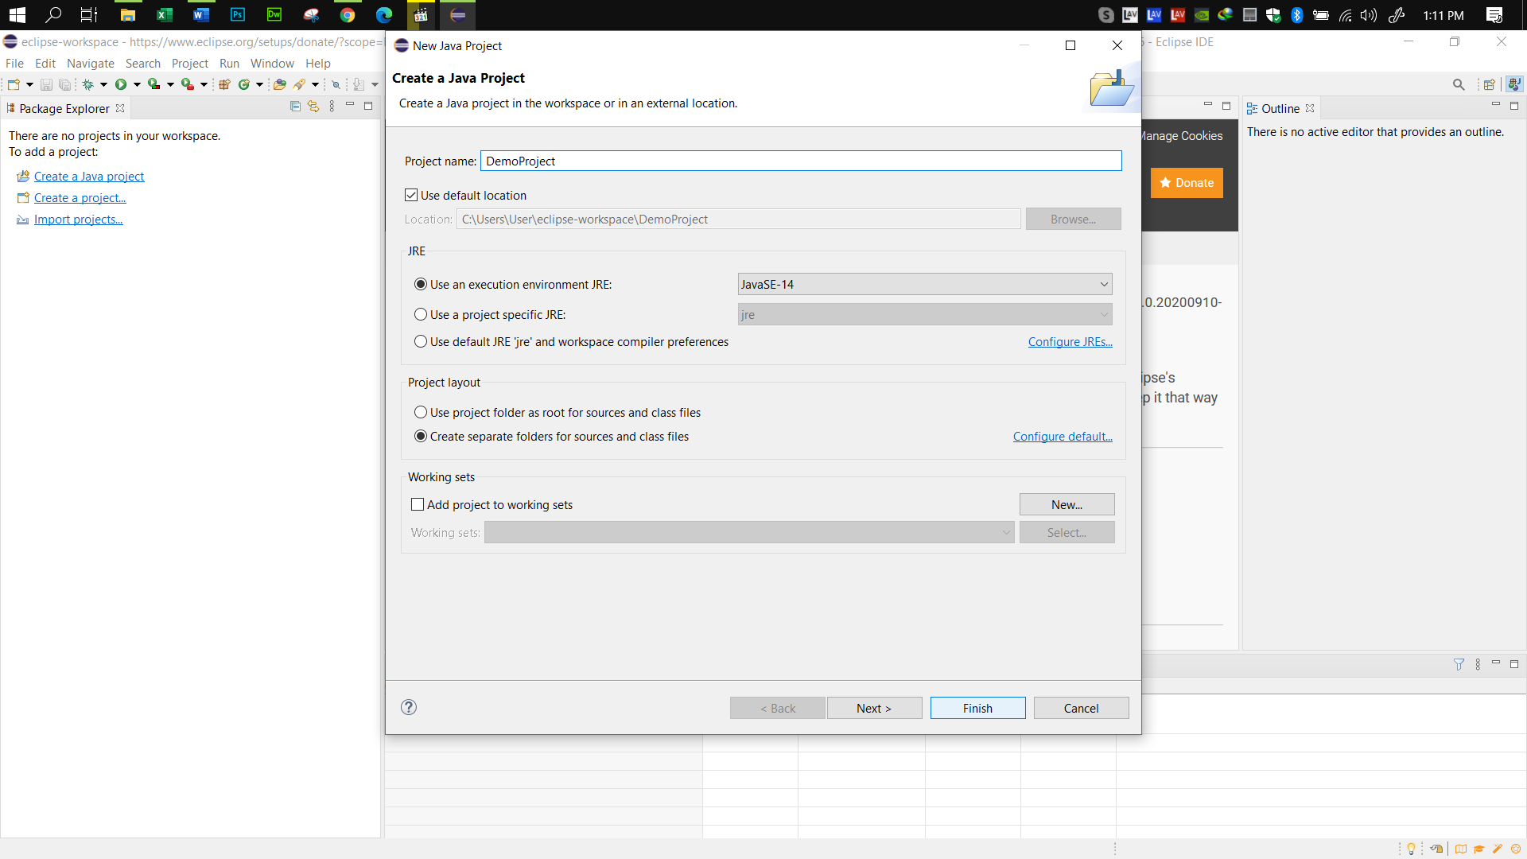

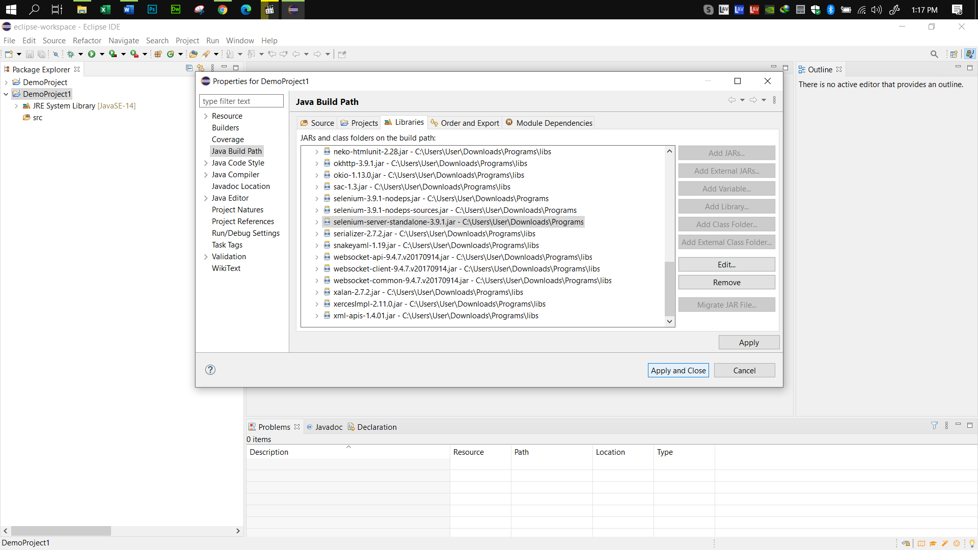

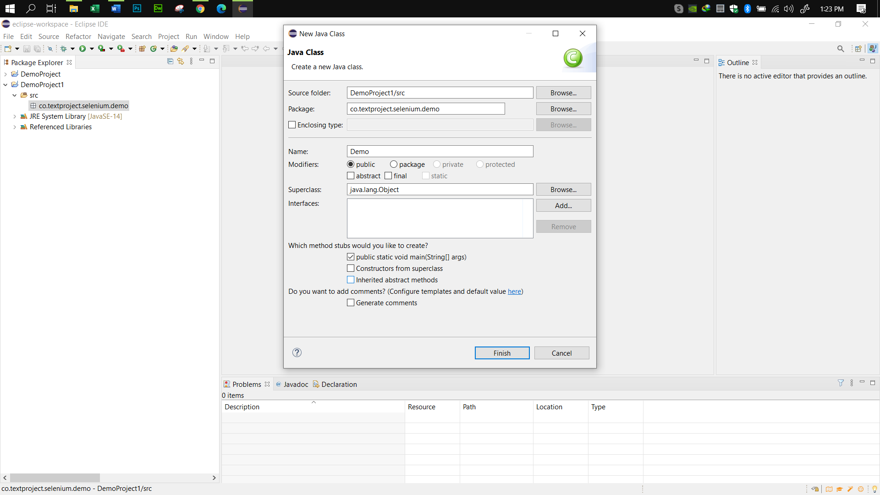

### Benefit of automated testing and specialty of Selenium:

There are huge benefits of automated testing. For gaining a faster feedback cycle it is very essential. Sometimes it gives better accuracy than manual testing. It can eliminate the human errors. Automated tesing provides more features than manual testing. For example simulating thousands of virtual users interacting with a web application in order to see how the application behaves. It’s impossible to simulate this kind of behavior by doing manual testing.

Selenium is an open source automation testing tool which is used for automating tests. It used to automate the testing process. One of the most valuable benefit of Selenium is , it’s a open source tool. Anyone can use it for free. It supports all major languages like Java, Python, JavaScript, C#, Ruby, and Perl programming languages for software test automation. It is yet a highly portable tool that supports and can work across different operating systems like Windows, Linux, Mac OS etc. Its not so difficult to learn and use.

### All screenshots of dummy project testing in Selenium during the practice:

Test-1:

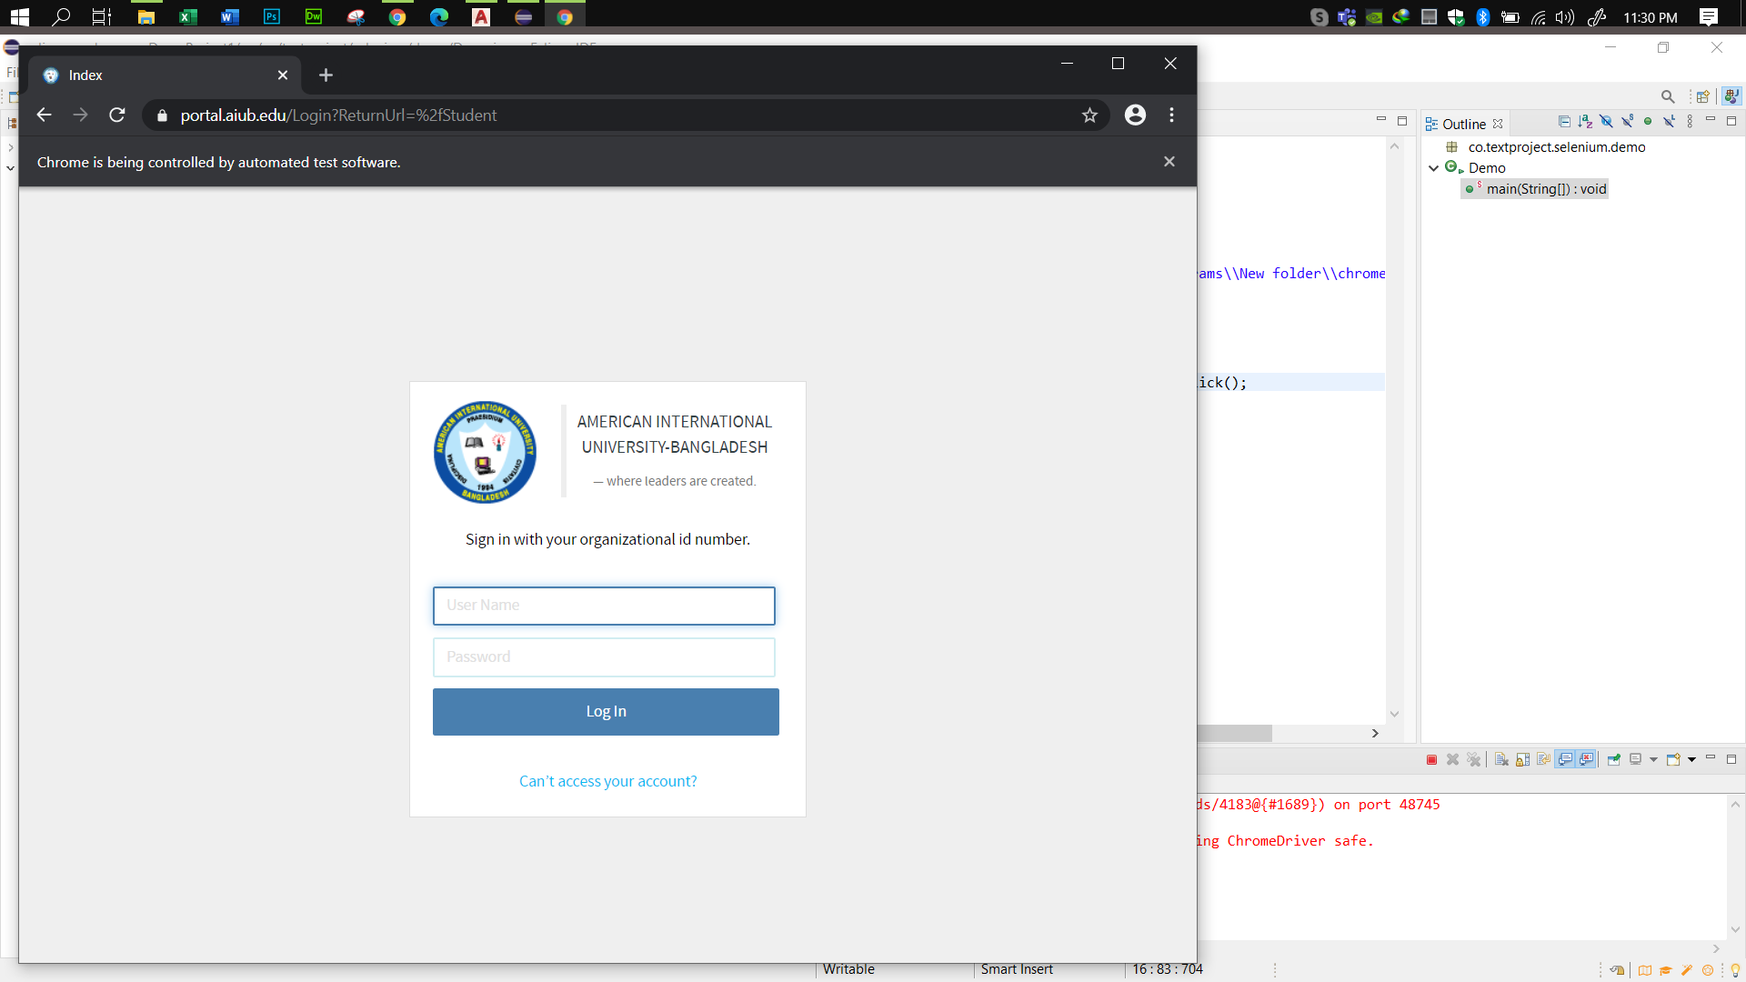

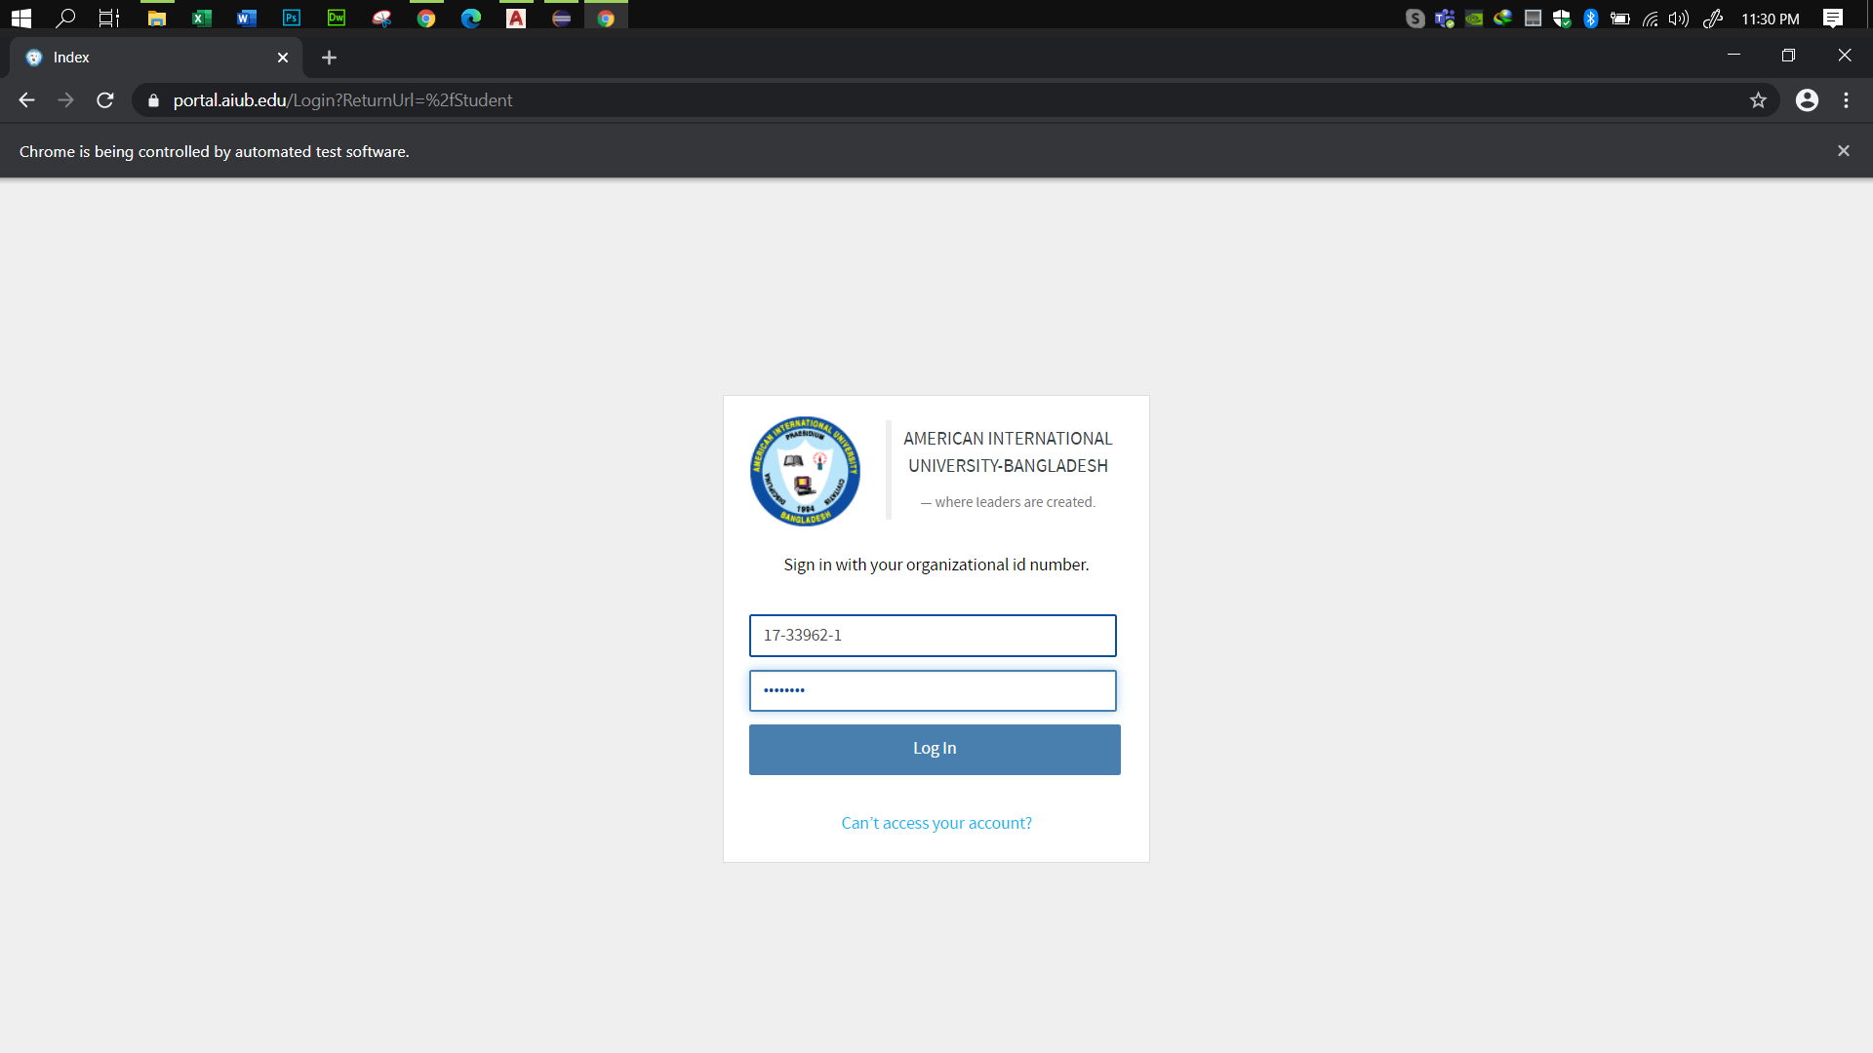

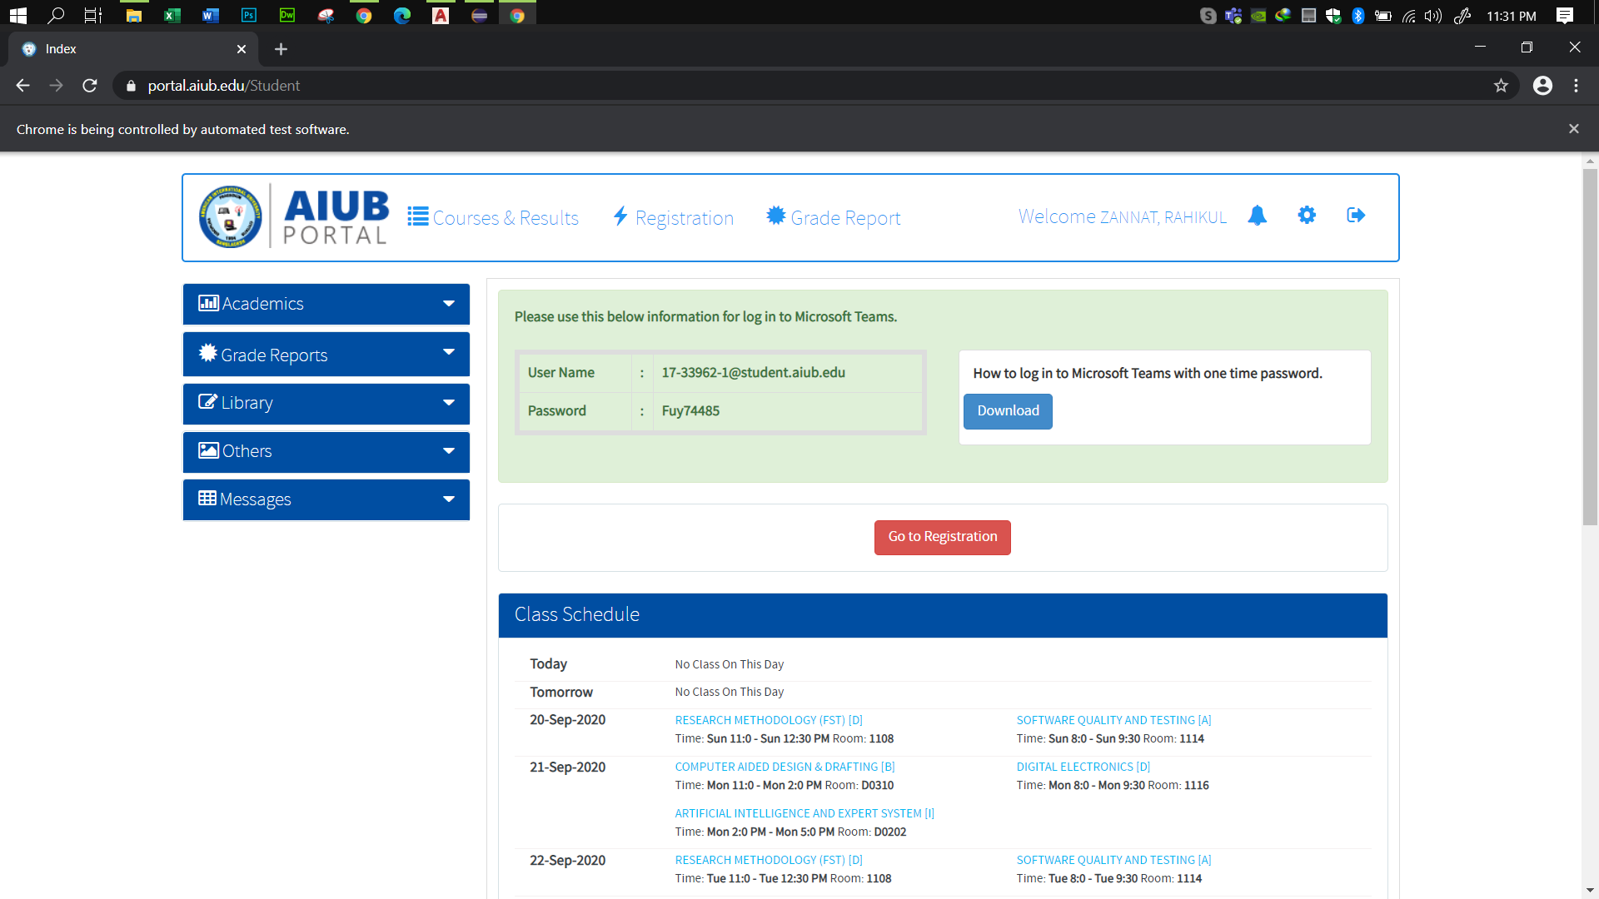

Test-2:

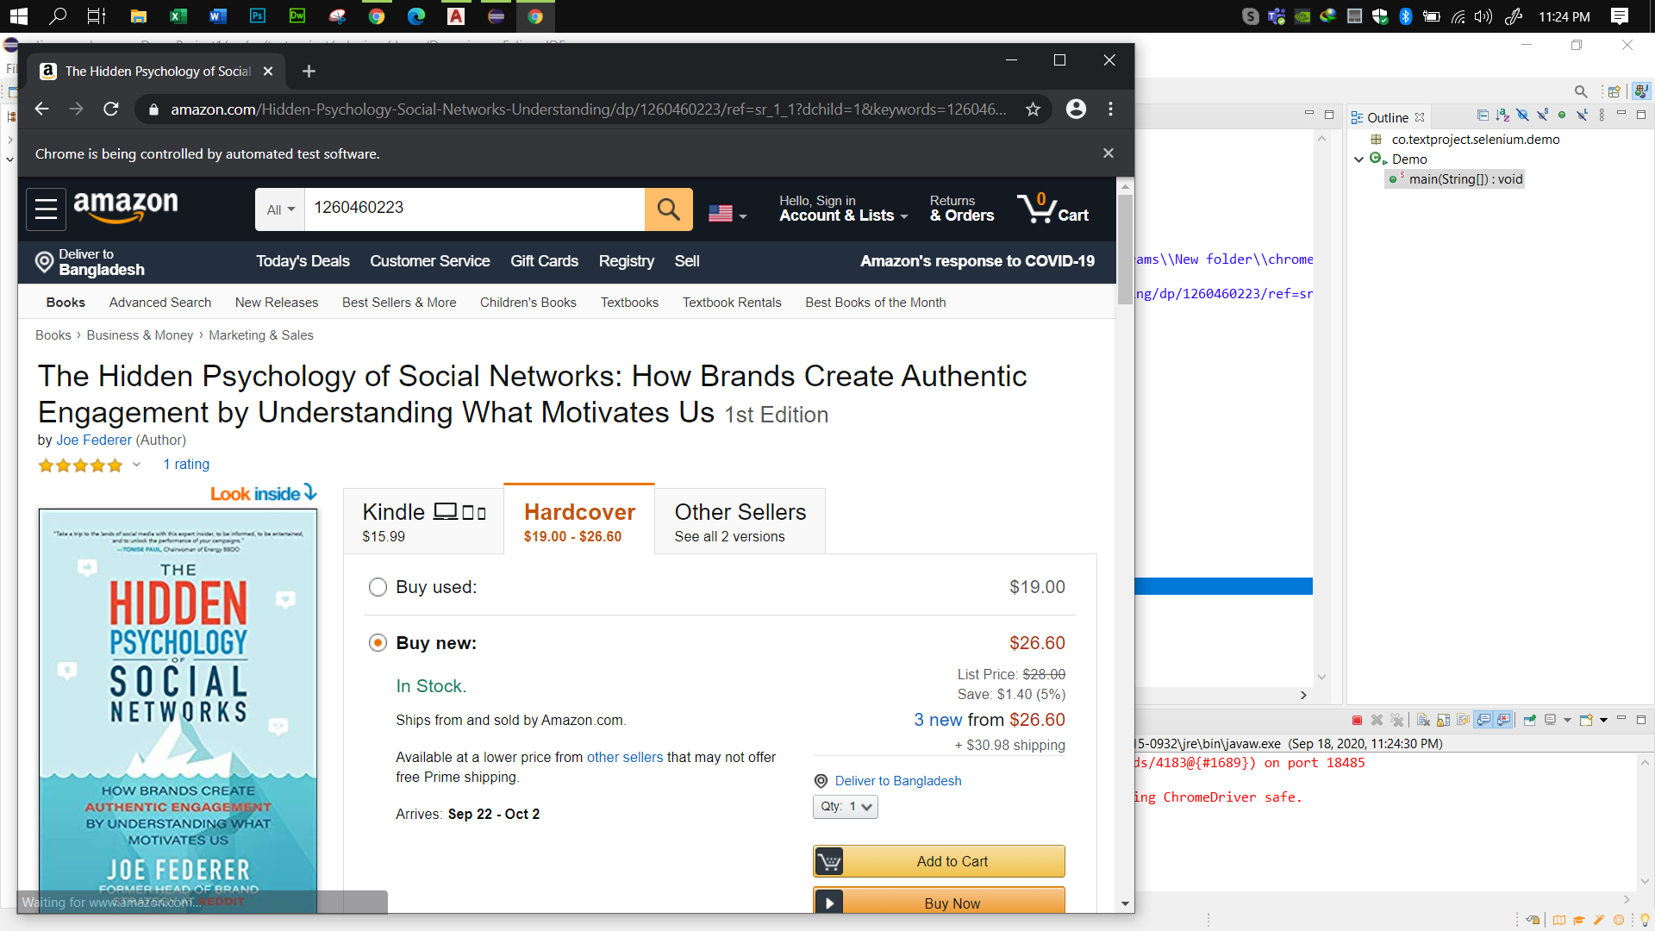

Test-3:

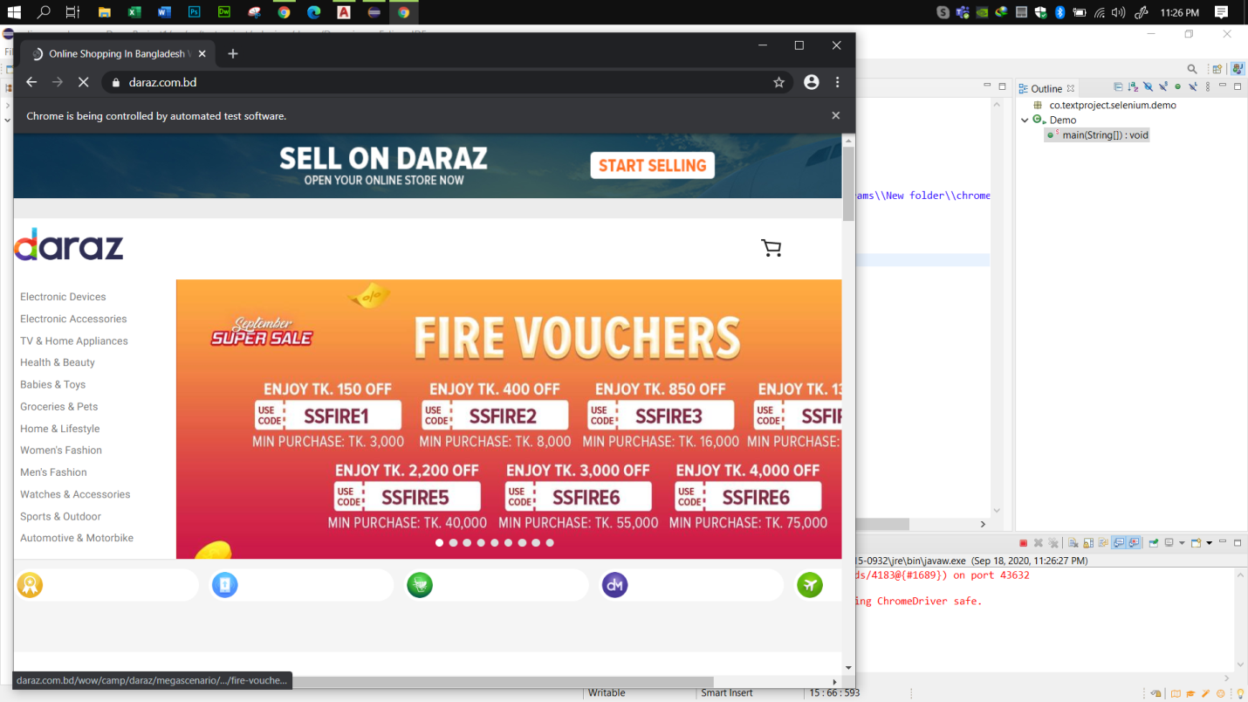

### All the test results of practice:

In this dummy Project we tested our project in Selenium. And all our tests are successfully done. We show all our test results with screenshots during the practice in below-

